**Save the Date**

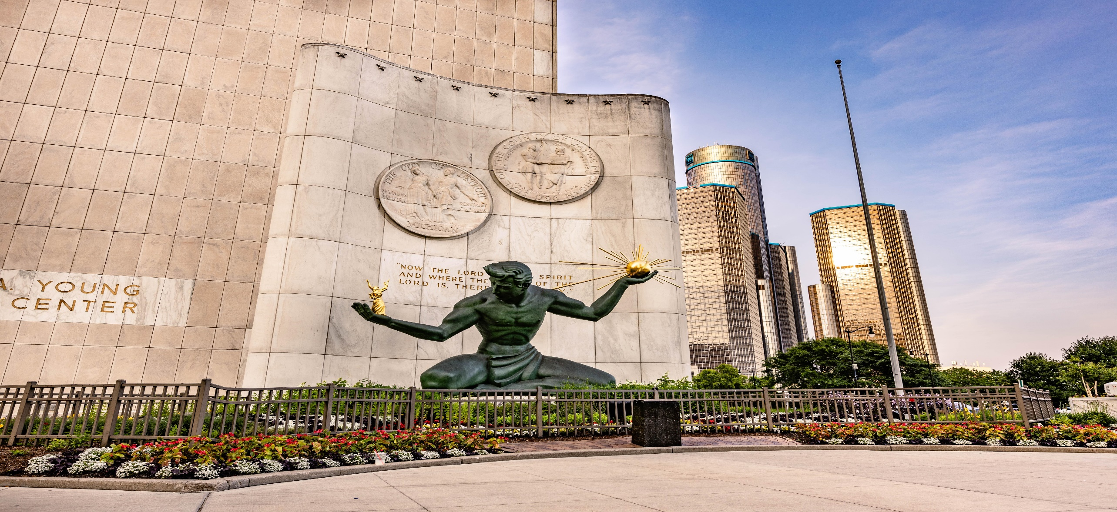**Friday, July 11, 2025 – Sunday, July 13, 2025**

**The Metro Detroit Family is looking forward hosting you for the:**

**54th Annual Peter Rice Family Reunion**

**Live in** D**etroit**

**You can begin booking your stay now!**



[**Fort Pontchartrain Detroit, a Wyndham Hotel**](https://www.wyndhamhotels.com/wyndham/detroit-michigan/fort-pontchartrain-detroit-a-wyndham-hotel/overview)

**2 Washington Blvd, Detroit, Michigan 48226**

**1-313-662-9477**

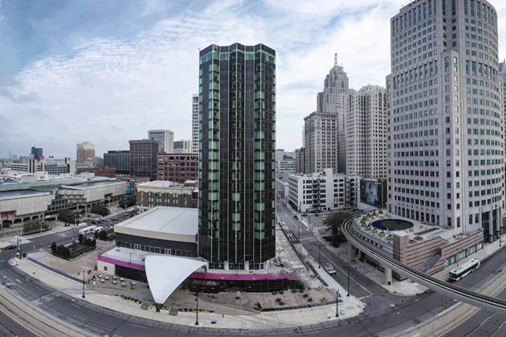<https://www.wyndhamhotels.com/hotels/55399?checkInDate=07/10/2025&checkOutDate=07/14/2025&groupCode=071025PET>

Photo Credits: Wyndham Hotels & VisitDetroit.com